**Spatial patterns in near bottom oceanographic variables collected during AFSC bottom trawl survey of the Aleutian Islands**

Principal Investigators - Chris Rooper (AFSC – RACE), Pamela Goddard (AFSC-RACE), Jerry Hoff (AFSC – RACE)

Contact: Chris.Rooper@noaa.gov

**Last updated: October 2016**

**Description of index**: In 2012 the RACE Division purchased four SeaGuard CTD units (funded by the North Pacific Research Board and Deep Sea Coral Research and Technology Program). These units were purchased to increase the oceanographic data collections during bottom trawl surveys of the eastern Bering Sea slope, Gulf of Alaska and Aleutian Islands.

The CTD units collect concurrent depth, temperature, salinity, pH, oxygen and turbidity data. The units are deployed on the headrope of the AFSC bottom trawls during most survey hauls. To date, the data has been collected on the 2012 and 2016 EBS slope, the 2013 and 2015 GOA, and the 2014 and 2016 Aleutian Islands bottom trawl surveys.

The data is presented here as a series of maps of bottom variables (the average value of each variable during the on-bottom period of the bottom trawl haul). The data have been interpolated to a 1 km by 1 km raster using R software. For temperature, salinity, pH and oxygen kriging with a fitted exponential semi-variance model was used based on the spatial pattern in semi-variance plots. The turbidity data exhibited a linear decrease in semi-variance with distance, so inverse distance weighting was used for this variable. In the Aleutian Islands in 2014, there was no data collected east of Seguam Island, while in 2016 there is a gap in data collection between Samalga Pass and Petral Bank (Figure 1). There were more than twice as many samples (n = 127) collected in 2014 than in 2016 (n = 52). The Aleutian Islands data were not corrected for time of the year, so some within-season temporal effects could be present because of the prosecution of the survey from east to west in the AI from June to August.

**Status and trends**: Bottom temperature appeared to be higher in 2016 than 2014 in areas where measurements were collected in both seasons (Figure 2). Consistent spatial patterns in the temperature and salinity data across were not apparent. However, salinities measured in both years ranged only from ~32-35 ppt. Oxygen concentrations were similar between 2014 and 2016 in the western Aleutian Islands, where there were some areas of low oxygen concentration in the farthest western areas of the survey. The central AI in 2014 had higher oxygen concentrations than other areas of the survey, with the exception of Unimak Pass in 2016. pH was not collected in 2016 due to equipment failure. pH and oxygen varied spatially in the Aleutian Islands and also changed with depth. Both variables exhibited lower values on underwater banks (such as Petral Bank) and generally the two values appeared to be correlated in 2014 and 2016. There were very low values of turbidity in 2014. This is very suspicious and may be the result of instrument failure. Values of turbidity were highest in 2016 in the southern Bering Sea and near Buldir Strait.

**Factors causing observed trends**: The observed spatial trends in near bottom temperature and salinity are likely due to the relatively oceanic regime in the Aleutians west of Samalga Pass. The warmest and freshest water was found in the eastern Aleutian Islands and southern Bering Sea where Gulf of Alaska oceanography may have higher influence on water properties than in the central and western AI. The observed trends in oxygen and pH in the Aleutian Islands are probably a result of the interaction between depth and currents moving through the passes. The turbidity is suspicious given the magnitude of the difference between the two years (all values < 1 in 2014 and up to ~20 in 2016).

**Implications**: As more of this data is collected relationships between fish and invertebrate distributions will be explored. When multiple years of data have been collected for each area, variability of spatial patterns may be important.

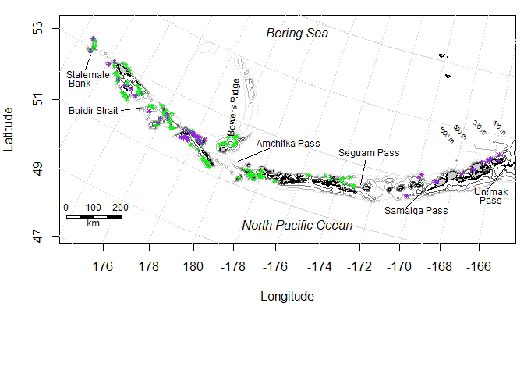

Figure 1. Locations for 2014 (green, n = 127) and 2016 (purple, n = 52) CTD deployments on the headrope of the bottom trawl used in the Aleutian Islands bottom trawl survey.

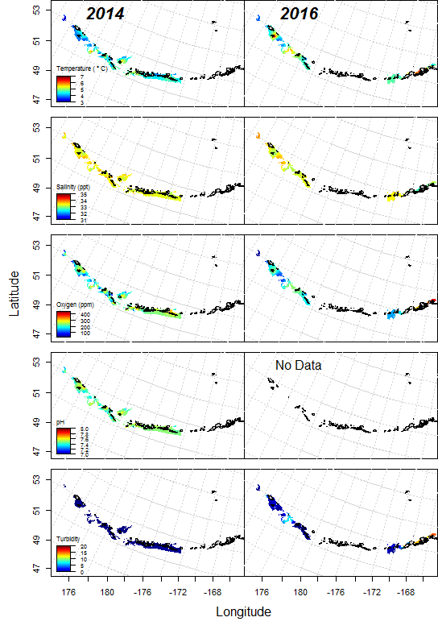

Figure 2. Spatial patterns in oceanographic variables (temperature, salinity, O2, pH and turbidity) measured on the seafloor during bottom trawl hauls in the Aleutian Islands grounfish survey in 2014 and 2016.